

root@cyberster:~$ whoami
> hanzallah — soc_intern
DAY
01
NETWORKING FUNDAMENTALS FOR SOC
// candidate Hanzallah
// program Cyberster — Cybersecurity Internship (Batch 2)
// tutor Abdullah Zia
[ STATUS: TASKS COMPLETE — READY FOR REVIEW ]
// 01 PLANNED LAB TOPOLOGY

Shows the three VMs, their adapters, and which network each adapter connects to.
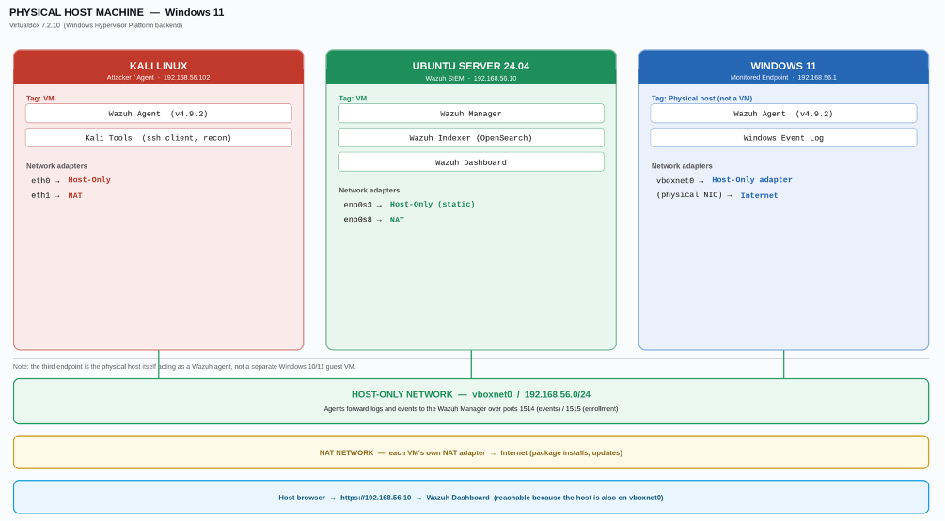

// 02 PROTOCOL SUMMARY — IN MY OWN WORDS

$ TCP/IP vs OSI Model
Both models describe how data moves from one device to another, just with different levels of detail. TCP/IP uses 4 layers and is what actually runs in real networks. OSI splits things into 7 layers and is mostly used for teaching. When my browser sends a request, the message gets wrapped layer by layer => application data, then TCP for ordering, then IP for addressing, then the physical network layer----- and the receiving machine unwraps it in reverse. That's the part that actually matters: every layer adds its own wrapper around the one before it. ____________________________________________________

$ Subnetting / CIDR
A subnet mask just tells you how much of an IP address is the "network part" vs the "device part." With a /24, the first three numbers have to match for two devices to be on the same network and talk directly without a router. So 192.168.56.10 and 192.168.56.20 can talk directly. 192.168.56.10 and 192.168.1.20 can't different network, needs a gateway in between. I don't need to do full binary math for this, just compare the matching octets.

$ Common Ports & Services
PORT | SERVICE
22 | SSH — Secure Shell
80 | HTTP
443 | HTTPS / TLS
25 | SMTP
53 | DNS
445 | SMB
3389 | RDP
8080 | Alt HTTP

$ ARP / DNS / HTTP / HTTPS / ICMP — function + suspicious indicators
• ARP finds a MAC address when you already know the IP --- local network only. Suspicious if a device suddenly claims to be the gateway (spoofing).
• DNS turns a domain name into an IP address. Suspicious if it's resolving weird random domains or returning the wrong IP for a known site.
• HTTP is the actual webpage request, sent in plain text --- readable in Wireshark. Suspicious if sensitive data (passwords) is sent unencrypted.
• HTTPS/TLS is the same thing, encrypted. You see the handshake but not the content. Suspicious if it's using an old TLS version or an untrusted certificate.
• ICMP is just a "are you alive" ping. Suspicious if the payload is unusually large or doesn't look like normal filler --- that's a known way attackers smuggle data out (ICMP tunneling), since ping traffic doesn't usually get watched closely.

// 03 WIRESHARK CAPTURE ANALYSIS

10-minute capture of normal browsing traffic — five protocols identified below.
$ Capture Overview
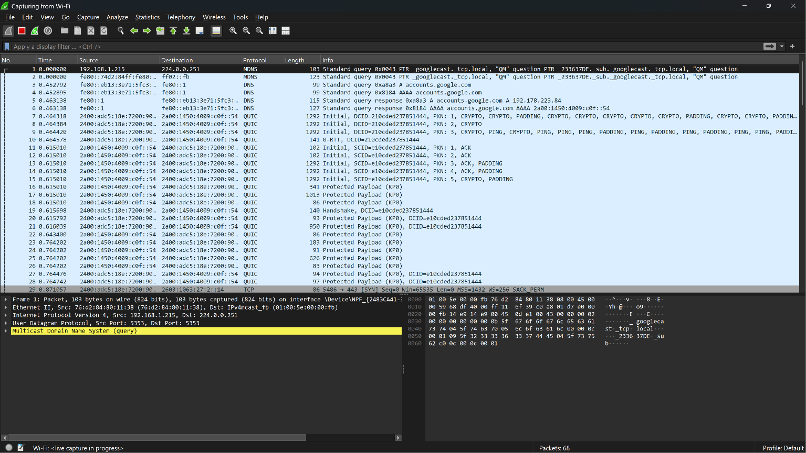$ Protocol 1 — ARP
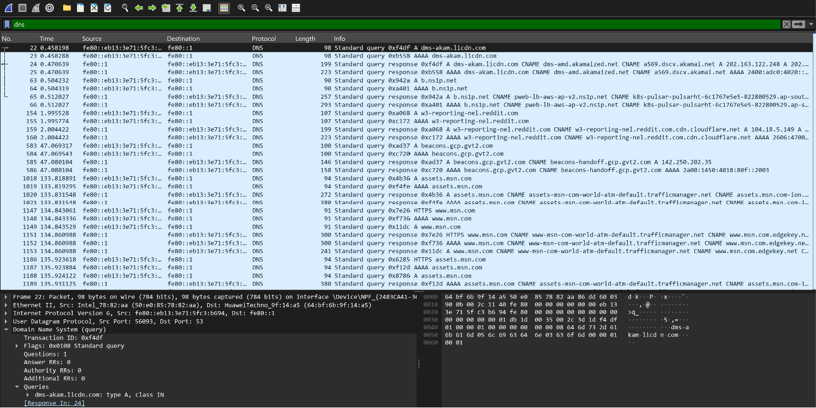
// note: "This is an ARP request packet 1277. Huawei device (192.168.1.7) is asking "who has 192.168.1.1?" since it only knows the IP, not the MAC. Target MAC is blank/zero because that's exactly what's being asked for. Whoever owns 192.168.1.1 will reply directly with their MAC address."
_____________________________________________
$ Protocol 2 — DNS
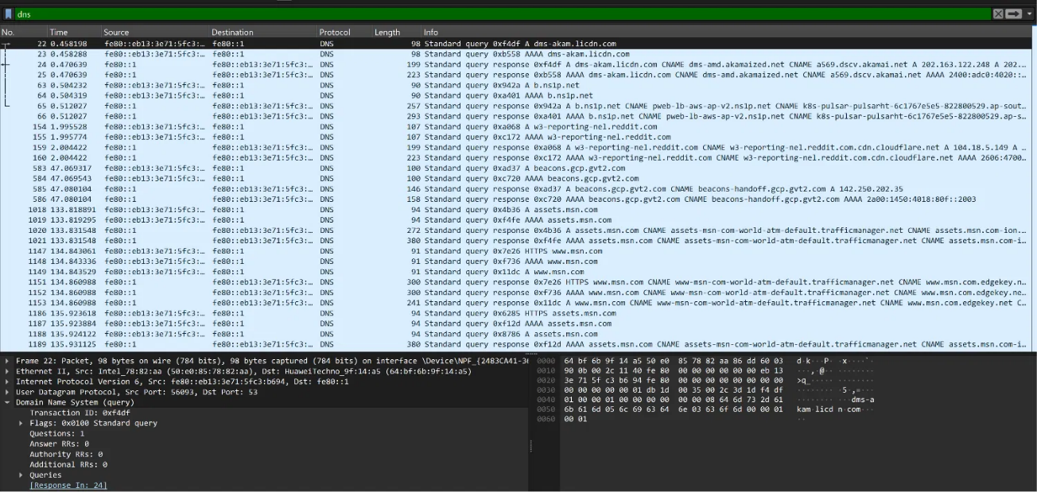
//note: "Packet 22 is a DNS query asking for the IP address of dms-akam.licdn.com (a LinkedIn-related domain). Packet 24 is the matching response, resolving it to an IP via a CNAME chain through Akamai's CDN."
_____________________________________________
$ Protocol 3 — HTTP
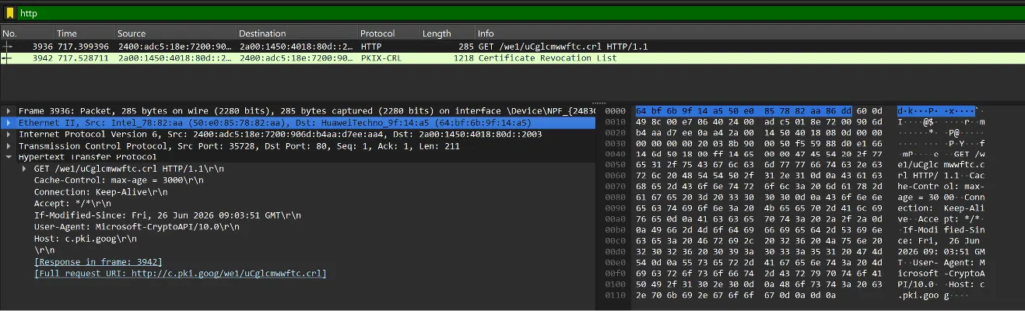
// note: "Packet 3936 is an HTTP GET request to c.pki.goog, asking for we1/uCglcmwwftc.crl. This isn't a webpage — it's Microsoft's CryptoAPI checking if a certificate has been revoked (a Certificate Revocation List). The "User-Agent: Microsoft-CryptoAPI" confirms it's an automatic background check, not something I clicked. Packet 3942 (PKIX-CRL) is the actual response containing the revocation list." _____________________________________________
$ Protocol 4 — HTTPS / TLS
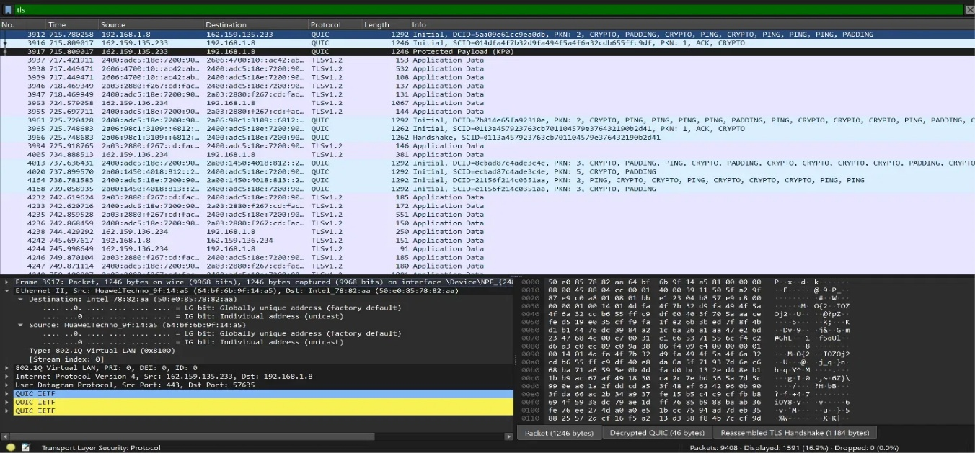
// note: "Modern HTTPS traffic to CDN-fronted services increasingly uses QUIC (HTTP/3) instead of TCP+TLS. The TLS 1.3 handshake is tunneled inside QUIC's encrypted CRYPTO frames rather than appearing as plaintext-visible TLS records. From a SOC perspective, this matters because traditional TCP-based TLS inspection tools may not see QUIC traffic at all unless they specifically support UDP/443 QUIC decryption making QUIC a potential blind spot for traffic visibility unless properly instrumented."
_____________________________________________
$ Protocol 5 — ICMP
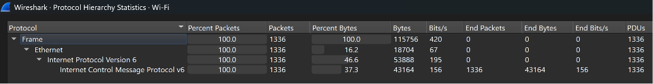
// note: "Protocol Hierarchy analysis revealed no ICMPv4 traffic in this capture, while ICMPv6 was actively present (Neighbor Solicitation/Advertisement messages). This reflects the IPv6-first nature of the test network — major destinations observed (Cloudflare, Meta/Facebook infrastructure) were reached over IPv6, with ICMPv6 handling address resolution and neighbor discovery in place of ARP/ICMPv4. This is consistent with the broader industry trend toward IPv6 adoption."
___________________________________________

